**Hello Team!** **Consider the below two tables**:

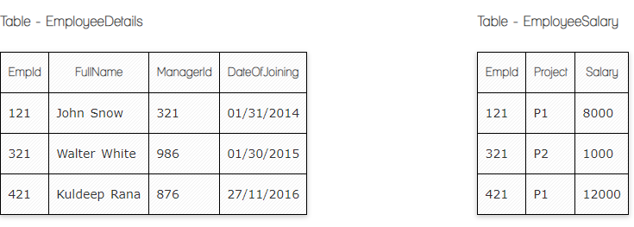

**Ques.1. Write a SQL query to fetch the count of employees working in project 'P1'.**SELECT *

**Select count**(Empld)

**From** EmployeeSalary

**where** project ='P1'

**Ques.2. Write a SQL query to fetch employee names having salary greater than or equal to 5000 and less than or equal 10000.**

**SELECT** FullName

**FROM** EmployeeDetails

**INNER JOIN** EmployeeSalary

**ON**EmployeeDetails.Empld = EmployeeSalary.Empld

**WHERE** Salary BETWEEN 5000 AND 10000

**Ques.3. Write a SQL query to fetch count of employees sorted by project's count in descending order.**

**Select Count**(EmpID), Project

**From** EmployeeSalary

**Group By** Projects

**ORDER BY COUNT**(EmpID) **DESC**

**Ques.4. Write a query to fetch employee names and salary records. Return employee details even if the salary record is not present for the employee.**

**SELECT** FullName, Salary

**FROM** EmployeeDetails

**LEFT JOIN** EmployeeSalary

**ON**EmployeeDetails.Empld = EmployeeSalary.Empld

**Ques.5. Write a SQL query to insert new record to the EmployeeDetails table with any data.**

**INSERT INTO** EmployeeDetails (EmployeeID, FullName, ManagerID, DateofJoinig)  
**VALUES** ('672', 'John Smith, '432', '25/12/2018')

**Ques.6. Write a SQL query to update EmployeeSalery table with setting Salary to 2000 for Project P2.**

**UPDATE**EmployeeSalery  **SET**Salary = ’2000’ **WHERE**Project=’P2’